A Week in Review
Alex Shvartsman
Welcome to a new weekly column here at The Sideboard. The title is pretty descriptive, as this column will discuss anything and everything that happened over the course of the last week in the world of Magic.
Here's what happened this week:

GRAND PRIX: DALLAS
Players from Canada thrive on playing in Texas. Paul McCabe won Pro Tour: Dallas. Gary Krakower won GP Austin. Now Matt Vienneau defeated the field of over 300 players (some of the top competitors in the game among them) to win Dallas.
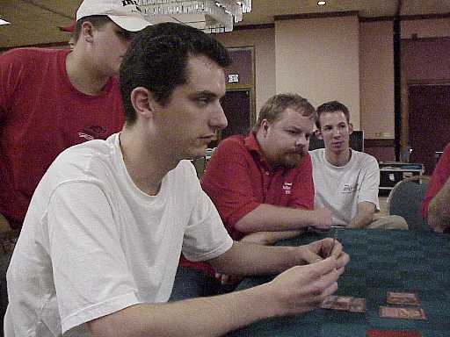
Vienneau has been around forever and is liked and respected by most other players. Although he has competed in a number of events, this is his first Top 8 finish in a very long time. His other top finish was an 8th place at Pro Tour: Atlanta. Online he is best known for his epic tournament reports. His report is on The Dojo.
Matt Vienneau will be attending Grand Prix: Kyoto and the Magic Invitational in Sydney later this month. He will not compete there - he will be doing tournament coverage for The Sideboard.
Click here for complete coverage of this tournament.

GRAND PRIX: HELSINKI

While Americans were busy losing to their neighbors from the North in Dallas, European pros gathered in Northern Europe to compete in Grand Prix: Helsinki. This is a first Grand Prix tournament to be held in Finland, and plenty of local players showed up. The total attendance was a little over 350, surprisingly beating out the attendance at Dallas.
Helsinki saw some old talent resurface. For example, PT Columbus champion Olle Rade made his first title event appearance since Pro Tour: Chicago last year. Rade did not manage to break into the top 64 though. Notably absent was Kai Budde. This is the first European Grand Prix he has missed since dominating the circuit two seasons ago. Budde had some bad luck and failed to make the top 64 in the last three Grand Prix in a row. He decided not to travel to Finland because of the sealed deck format, but will likely be attending the Extended GP Florence.
At the end of the day, Noah Boeken defeated the local pro Erno Ekebom. Boeken is having a very good year. He won the European Championship and made top 8 in Grand Prix Copenhagen and Manchester. Boeken was especially happy with this win because the 6 Pro Tour points he earned in Helsinki are just enough to qualify him for the Masters Series tournament at Pro Tour: Los Angeles.
Click here for complete coverage of this tournament.

COMING UP: STATE CHAMPIONSHIPS
Invasion became Standard legal as of November 1st. Say good bye to Masticore, Morphling and Replenish. Say hello to the tournament environment that has not been seen in Standard for many years.
Tournament veterans say that the new type 2 feels similar to that played around 1996-97. Cards like Wrath of God and Armageddon are suddenly major factors of the metagame again. Red-Green aggressive decks battle against Black-Blue or White-Blue control in a format that seems to lack combo decks and promote player interaction. Most players seem pleased with the new format and are excited about the upcoming tournaments that will use it.
State Championships are the first major series of tournaments to be using Invasion cards. It is eagerly anticipated as the event that will create the new metagame. States is an open tournament, so if you have some time this weekend and want to try out your new deck, check here for details.

COMING UP: NORDIC CHAMPIONSHIP
While State Championships are only held in United States, there are a number of other serious tournaments around the world scheduled to take place that same weekend in order to celebrate the new format. Perhaps the most important is the Nordic Championship.
A total of $10,000 in prize money is available to players from Scandinavian countries and Denmark. They will compete in a two day long event featuring Invasion draft and Type 2 on the same weekend as the State Championships.
You can find out more about this tournament at www.valhalla-magic.com.

EOTFOFYL!
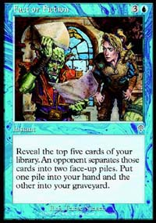
Eotfofyl!
Magic has spawned some strange jargon such as "mise" and "or no," but "eotfofyl?" Don't get too surprised if you hear this exclaimed at your next tournament. It simply means "End of turn Fact or Fiction, you lose!"
Just about everyone agrees that Fact or Fiction is the best card to come out of Invasion. Perhaps a little too good. Even before any major Standard tournaments, there are voices around the 'net discussing whether or not the card should be banned.
Another cute Fact or Fiction story is that in playtesting a lot of players have adopted the following protocol. Its caster will ask "Fact or Fiction?" when playing the card. His opponent will either say "Fact," allowing the spell to resolve or "Fiction" and attempt to counter it.

YOUR MANA'S WORTH: PHYREXIAN INFILTRATOR
Underappreciated cards and cool tournament tricks.
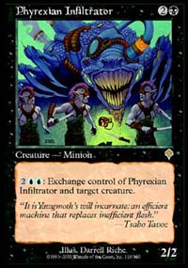
You do not have to give away your Phyrexian Infliltrator just to steal one of your opponent's creatures.
This neat trick requires you to have eight mana available. Activate Infiltrator's ability targeting your weakest creature. In response activate its ability targeting your opponent's best.
Both abilities will be placed on the stack. First, the latter will resolve exchanging control of Phyrexian Infiltrator for your opponent's creature. Then the second ability will resolve exchanging the Infiltrator for one of your own creatures.
Repeat any time your opponent has a creature in play that is better than one of yours and victory won't be far away.

TRADING TRENDS
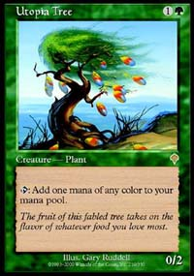
Invasion has a lot of very exciting rares that players are hurrying to get their hands on. Others are holding on to what new rares they've got for fear of trading away the Next Big Thing in exchange for some cards no one wants.
To let you trade with confidence, I have compiled a list of the top 10 most traded-for singles in Invasion. If you have one of them, do not trade it away at a low value. If you do not, it might be a good idea to pick some up.
- Utopia Tree
- Urza's Rage
- Undermine
- Blazing Specter
- Absorb
- Skizzik
- Kavu Titan
- The Dragons
- Teferi's Moat
- Tsabo's Web
There are a number of other hot rares such as Void and Pyre Zombie. A number of uncommon cards are extremely well traded-for, especially Fact or Fiction and the five tap lands (Salt Marsh, Shivan Oasis, etc.)

PLAYER OF THE YEAR RACE
Current top standings:
1 Johns, Scott 26
2 Wise, Gary 25
3 Turian, Michael 24
4 Boeken, Noah 16
5 Ruel, Antoine 14
5 Clegg, Dan 14
7 Ruel, Olivier 13
8 Kastle, Darwin 12
8 Johnson, Andrew 12
8 Fuller, Ryan 12
8 Forsythe, Aaron 12
8 Cuneo, Andrew 12
Player of the Year race does not get really interesting until at least two Pro Tours into the season. Until then, a team or player who has won the first Pro Tour clearly dominates the standings. That is the case here. Turian, Wise and Johns are on top. Turian did not attend GP Dallas, so his teammates raced ahead of him. Gary Wise picked up a point for his Top 32 finish while Scott Johns broke his streak of bad GP luck and made Top 16. Noah Boeken makes fourth on the strength of his Manchester and Helsinki finishes.

BEST OF THE NET
The best Magic read outside of The Sideboard this week, can be found on The Dojo. In his article, PT: NY runner up Aaron Forsythe describes how his team was put together, playtested, and finally succeeded at Pro Tour: New York. It is titled PTNY, Owen Meany, and the Myth Science Arkestra.
A special mention goes to www.neutralground.net as the site to offer some of the best coverage of the new Standard format. At this time, most pro players are reluctant to write about Standard because it is the format of an upcoming Pro Tour: Chicago. Neutral Ground offers a number of quality articles about the format. An excellent one to start off with is Sean McKeown's look at the Control In Type 2 featuring several deck lists.
Finally, Star City gets props for celebrating Halloween in style. They had their most popular feature authors swap columns and writing styles for a day, generating plenty of good fun.

PLAY OF THE WEEK
This cool play took place in a two on two team draft last week. My draft partner Alex Briggs was in serious trouble. He had several fliers in play, but they were no match for his opponent's horde of 3/3 ground creatures. Alex just took a whole lot of damage, going down to 4 life. It looked like he would not survive the following turn.
After the attack step, Alex's opponent tapped four mana and cast Breath of Darigaaz with kicker, hoping to finish the game right away. Alex responded by playing Orim's Touch with kicker! Not only did he take no damage, but every single creature on his opponent's side of the table died to this Earthquake-like spell. Flying creatures weren't affected and made short work of his opponent in a couple of turns.
This story doesn't end there! Having won the team draft, Alex and I participated in an 8 man Rochester draft, where Alex managed to draft not one, not two, but THREE Breath of Darigaaz!
General consensus was that he'd win the draft. However, he met the same exact fate as his opponent did in the previous draft. In the deciding third game, Alex cast Breath of Darigaaz for the win, only to have his opponent Brook North respond by casting Revitalizing Vapors and stay in the game, then eventually come back and win that match.
Know of a cool story that could become Play of the Week? Have suggestions for this column? News? Rumors? Please e-mail me at ashv@concentric.net.

